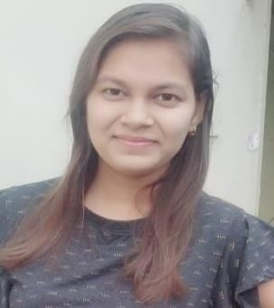

# PROFILE

I am an ambitious person, creative and innovative. I responsibly face challenges and goals, adaptable to changes, able to work with team, able to work calmly as well as to solve problems efficiently and goal oriented.

# TECHNICAL SKILLS

## LANGUAGES

C and C++ programming Python, HTML, CSS, Java Script **SUBJECTS**

Data Structure, DBMS, Operating System,

Web Development

## TRAININGS

Python with Data Science PCB Designing

IOT Training:- 5 days training

PREETI VERMA

Contact:- 6261446596

Email: - [vpreeti240@gmail.com](mailto:vpreeti240@gmail.com)

Address: - Shankar Nagar, Raipur (C.G)

# ACADEMIC DETAILS

* **B.Tech** 2018 – present Shri Shankaracharya Institute of Professional Management and Technology, Raipur
* **12th** 2018

Board: CBSE

Percentage: 78. 4%

* **10th** 2016

Board : CBSE CGPA: 8.6

# SOFT SKILLS

* Problem solving
* Team worker
* Disciplined
* Can Work Under Pressure
* Positive Attitude

# HOBBIES

* Dancing
* Drawing
* Playing Volleyball

# ACHIEVEMENTS

* Bridingo :- Successfully cleared Round 1 and was amongst top 400 players in the National level Hackathon.
* Hacker rank <https://www.hackerrank.com/vpreeti240>
* Secured 2nd position in I AM SMARTICUS conducted by SSIPMT, Raipur

# PARTICIPATION

* Secured 2nd Position in Volleyball Match in SSIPMT Fest 2020
* Participated in Quriosity Quiz Event in SSIPMT Fest 2018
* Participated in Essay Writing Competition in SSIPMT Fest 2018